F.4 Bio Ch.11 Transport of Substances and Support in Plants – Supplementary Worksheet 1 p.11-4

Name: _____________________ ( ) F.4__ Date: ________________

How can water continuously lose from the stoma?
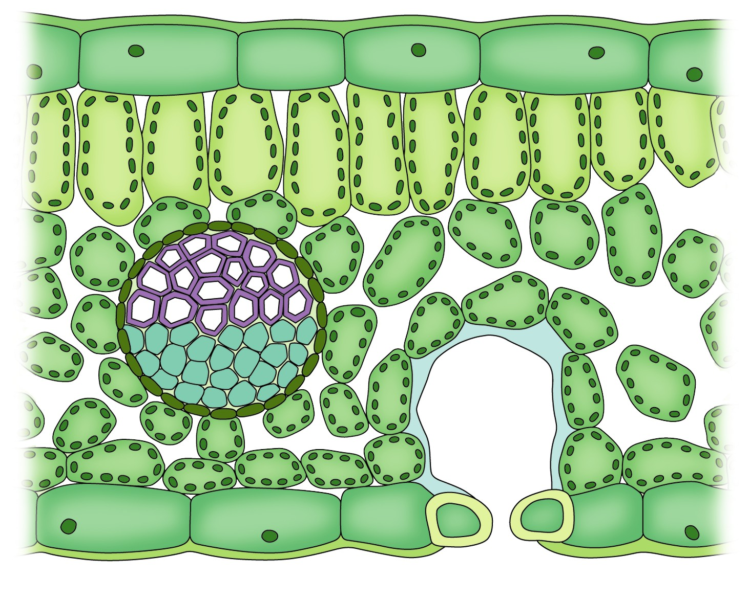
1
2
3a
3b
4

Step | Steps for water movement in plant | Key process
1 | Water on the surface of the mesophyll cells  into the air space. The air space becomes almost saturated with water  . | Process of transpiration  Creation of transpiration  .
2 | Water vapour out through the stoma, to the less air outside.
To replace the water lost to the air space, mesophyll cells around the air space draw water from neighbouring cells through the following two routes:
3a | Movement of water through by the process called ; since after losing water to the air space, the water potential of the mesophyll cells surrounding the stoma .
3b | Movement of water through , which is completely permeable.
4 | Water is finally drawn from the ,  which transport water continuously from the roots.

